**Installing CP2102 USB Driver V1.1**

**Note:-** These guides must be followed in the correct order  
ESP32 Installing CP2102 USB Driver  
ESP32 Arduino Software Load  
ESP32 Firmware Load

The CP2102 device driver does not normally come pre-installed on Windows and has to be installed manually.

**Connect the ESP32 board** to the compute using a suitable USB cable.

**Open Device Manager** by pressing Windows Key + X and selecting ‘Device Manager’

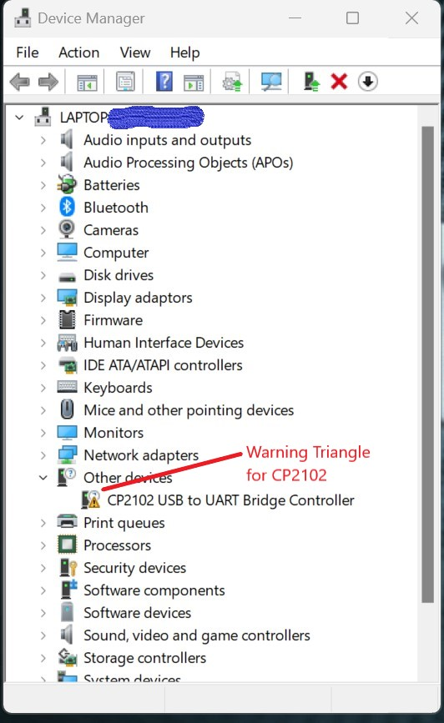

If you see a yellow ! triangle labelled CP2102, then drivers require installing.

Note:- the Ports (COM & LPT) may need expanding, to see the device.

**Step 1,**

Download the drivers from the link below.

Fow Windows users, select the top one, CP210x Universal Windows Driver

[CP210x USB to UART Bridge VCP Drivers - Silicon Labs (silabs.com)](https://www.silabs.com/developers/usb-to-uart-bridge-vcp-drivers?tab=downloads)

**Step 2**,

Navigate to the downloaded file (most likely in Downloads directory) Highlight it by clicking once, then right-click and select ‘Extract All’ and accept the default directory.

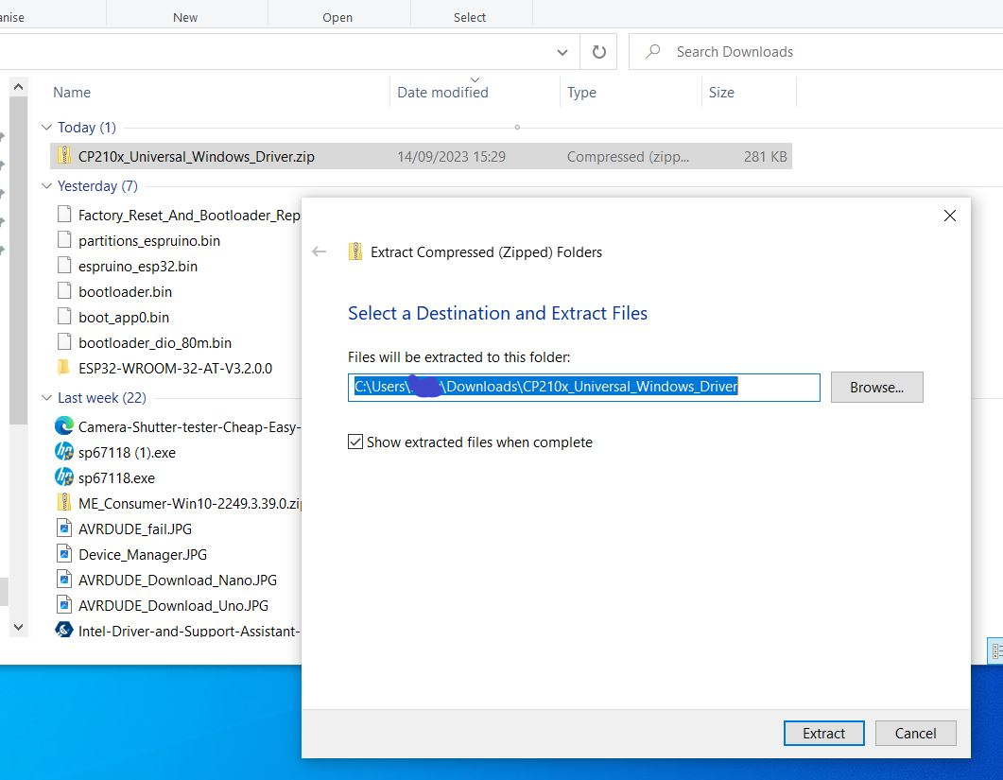

**Step 3,**

Go back to Device Manager and right-click on the Yellow ! Triangle   
select ‘Update Driver’ and then ‘Browse my computer for drivers’

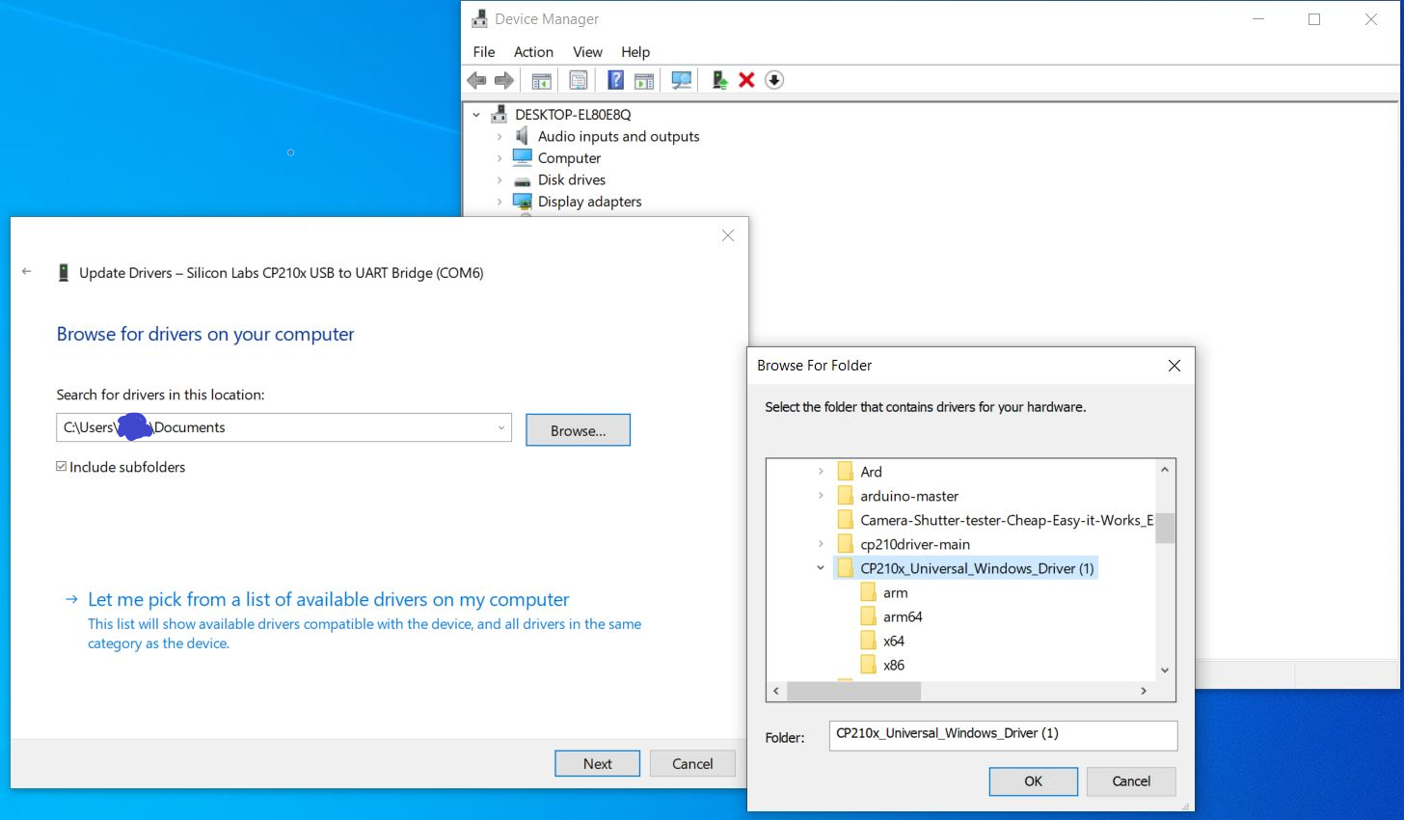

Click ‘Browse’ and navigate to the Downloads folder, find and click on the folder that was previously downloaded & extracted.

Click ‘Ok’ and then ‘Next; in the previous box and the drivers should be installed.

A computer re-start will be required to complete installation.